JOVSTACK
Multi-Tenant SaaS Platform
Entity-Relationship Diagram (ERD)
Database Design Specification — Version 1.1 (Draft for Review)
Scope: Platform Core + Website Builder + Basic Commerce (MVP)
Derived from the Domain Model in the Platform Architecture Specification v1.0 and the constraints in NFR v1.0.
Prepared by the Business Analysis & Project Management function · 30 May 2026

1. Document Control
Field | Value
Document Title | JovStack Entity-Relationship Diagram (Database Design)
Version | 1.1 (Draft for Review)
Supersedes | Version 1.0
Date | 30 May 2026
Source Documents | Platform Architecture Specification v1.0 (Domain Model); NFR v1.0
Target Database | PostgreSQL (accessed via Prisma)
Audience | Engineering, Architecture, QA
Revision History
Version 1.1 is an incremental update to v1.0. No existing entities, relationships or constraints were removed; the following were added.
Ref. | Change (v1.0 → v1.1) | Impact
A1 | Added Cart.organizationId (FK → Organization). | Cart becomes directly tenant-scoped; new relationship and tenant index.
A2 | Added Website.slug. | New UNIQUE(organizationId, slug) index; seeds the subdomain.
A3 | Added ContactRequest.subject and ContactRequest.phone. | Data dictionary only.
A4 | Added AuditLog.metadata, AuditLog.ipAddress, AuditLog.userAgent. | Richer audit records (NFR-S10).
A5 | Added RefreshToken entity (→ User). | New table, relationship, and indexes; supports session/token lifecycle (NFR-S09).

2. Introduction and Scope
This document translates the JovStack domain model into a database design for the MVP. It presents the entity-relationship diagram, a complete data dictionary, the relationship and referential-integrity specification, the indexing strategy, enumerations and the tenant-isolation constraints. It realises the entities and invariants defined in the Platform Architecture Specification §5 and the security and performance constraints of NFR v1.0 (notably NFR-S01 tenant isolation and NFR-PF05 query efficiency).
The design targets PostgreSQL with a shared-schema, shared-database multi-tenant model: every tenant-owned table carries a non-null organization_id and is governed by the isolation controls defined in the Architecture Specification §3.

3. Notation and Conventions
The diagram uses crow's-foot notation. Keys and constraints follow the conventions below.
Notation | Meaning
–| (bar) on parent end | Exactly one (the “1” side)
crow's foot on child end | Many (the “N” side)
solid line | Mandatory relationship (FK NOT NULL)
dashed line | Optional relationship (nullable FK)
id (bold, underlined) | Primary key (PK)
field (italic) + FK | Foreign key; FK? denotes a nullable foreign key
UQ | Unique constraint on the column

- All primary keys are UUID.
- Monetary values use numeric(12,2) with a CHECK >= 0 constraint.
- Timestamps are timestamptz; soft-deletes use a deletedAt / status marker and are excluded from default queries.

4. Entity-Relationship Diagram
Colour denotes the owning module: Core (dark), Billing (blue), Builder (purple), Commerce (green), Media (amber), Global (grey). Diagram boxes show keys and foreign keys; full attributes appear in the Data Dictionary (§5).
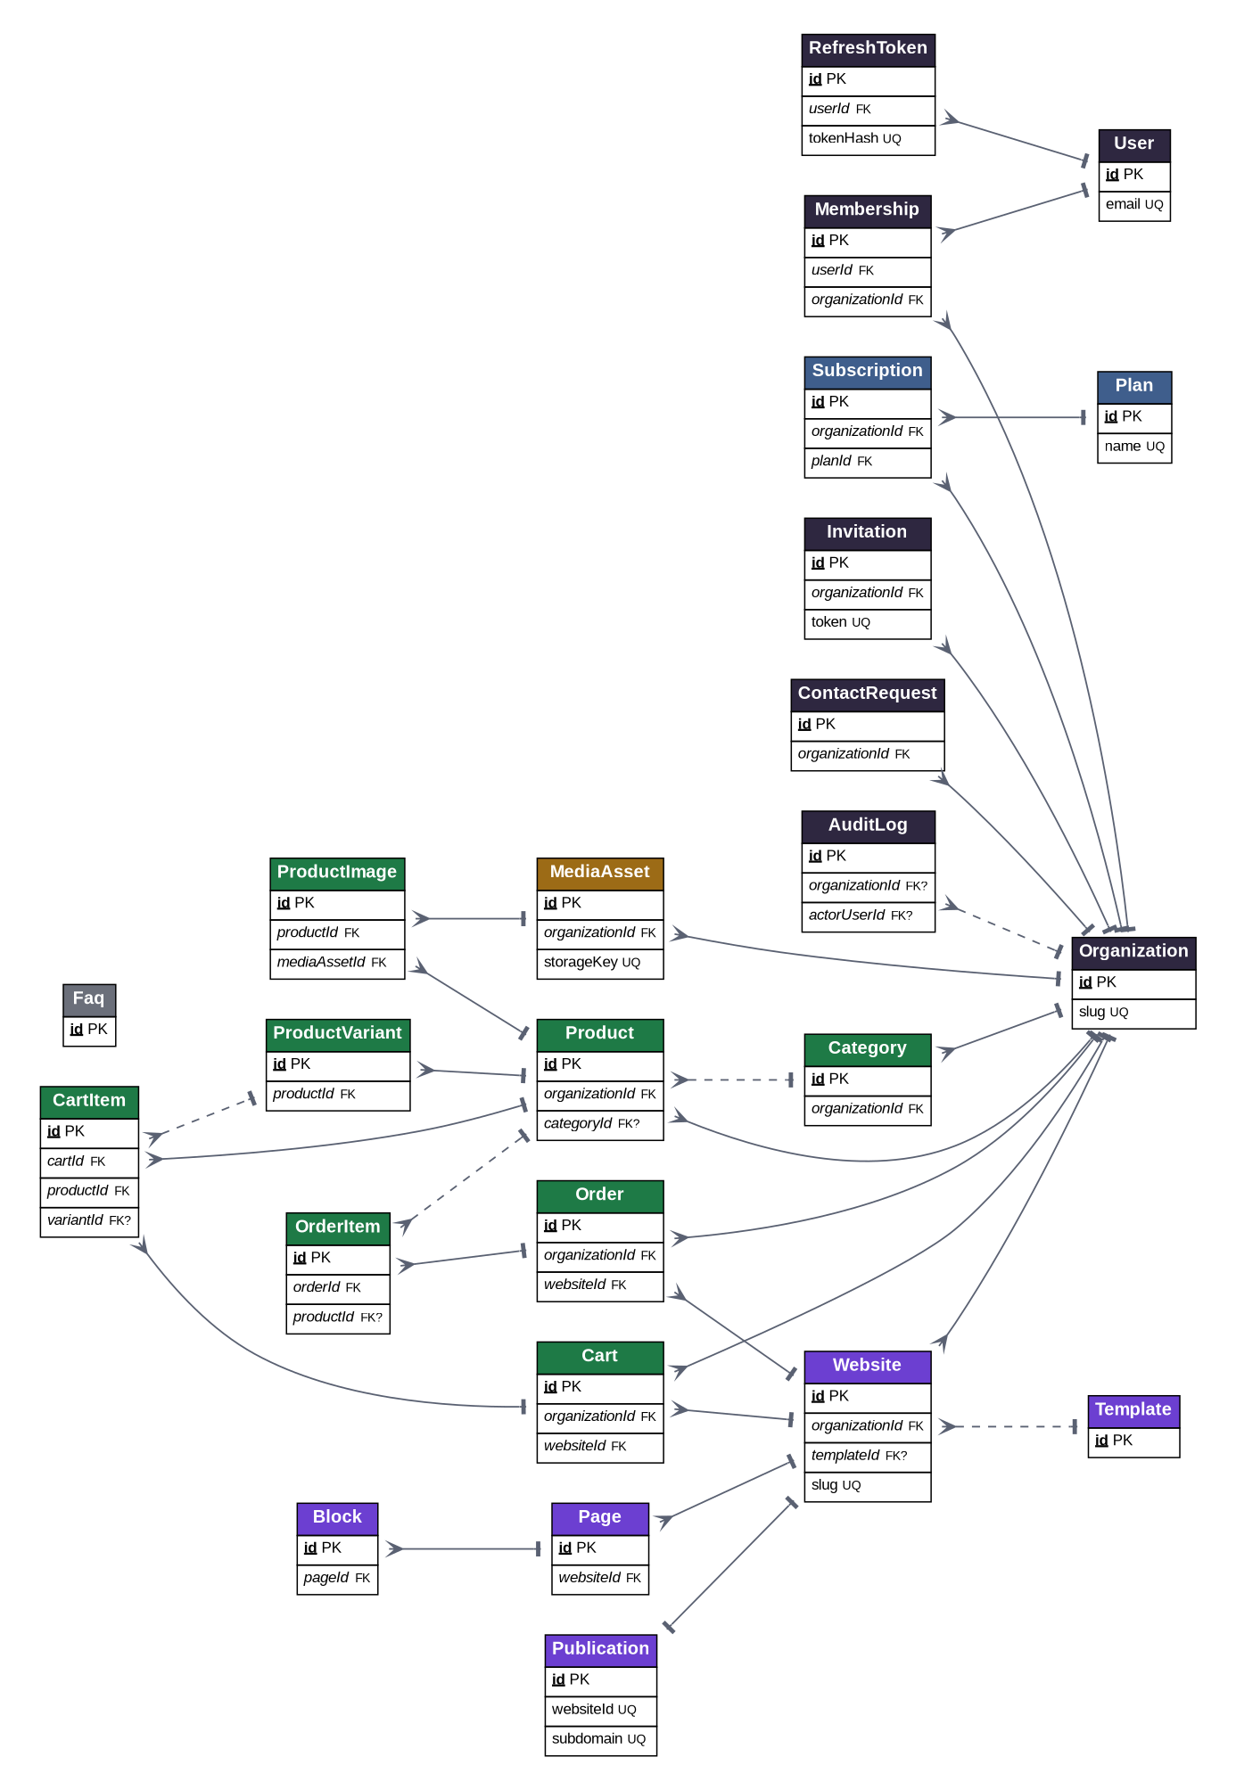

5. Data Dictionary
Each entity is listed with its fields, types, key designation and constraints. Key codes: PK primary key, FK foreign key, FK? nullable foreign key, UQ unique.

User
Global — not tenant-scoped.
Field | Type | Key | Constraints / Notes
id | UUID | PK
email | varchar | UQ | Unique; login identity
name | varchar
passwordHash | varchar |  | Argon2id (NFR-S02)
status | enum |  | User.status
emailVerifiedAt | timestamptz |  | Null until verified (FR-102)
createdAt | timestamptz
updatedAt | timestamptz

Organization
Tenant root — the unit of isolation.
Field | Type | Key | Constraints / Notes
id | UUID | PK | Tenant identifier
name | varchar
slug | varchar | UQ | Basis of publishing subdomain
status | enum |  | Organization.status
createdAt | timestamptz
updatedAt | timestamptz
deletedAt | timestamptz |  | Soft-delete marker (NFR-P04)

Membership
Tenant-scoped. UNIQUE(userId, organizationId).
Field | Type | Key | Constraints / Notes
id | UUID | PK
userId | UUID | FK | → User
organizationId | UUID | FK | → Organization (tenant key)
role | enum |  | Membership.role
status | enum |  | Membership.status
createdAt | timestamptz

Invitation
Tenant-scoped.
Field | Type | Key | Constraints / Notes
id | UUID | PK
organizationId | UUID | FK | → Organization (tenant key)
email | varchar |  | Invitee
role | enum |  | Role to assign on accept
token | varchar | UQ | Single-use
status | enum |  | Invitation.status
expiresAt | timestamptz
createdAt | timestamptz

Plan
Global catalogue (dynamic pricing).
Field | Type | Key | Constraints / Notes
id | UUID | PK
name | varchar | UQ
price | numeric(12,2) |  | CHECK >= 0
interval | enum |  | Plan.interval
features | jsonb |  | Entitlements
isActive | boolean |  | Deactivation (FR-706)

Subscription
Tenant-scoped. One active per organization.
Field | Type | Key | Constraints / Notes
id | UUID | PK
organizationId | UUID | FK | → Organization (tenant key)
planId | UUID | FK | → Plan
status | enum |  | Subscription.status
currentPeriodEnd | timestamptz |  | Null for Free
createdAt | timestamptz

Template
Global starter layouts.
Field | Type | Key | Constraints / Notes
id | UUID | PK
name | varchar
category | varchar
isActive | boolean

Website
Tenant-scoped. UNIQUE(organizationId, slug).
Field | Type | Key | Constraints / Notes
id | UUID | PK
organizationId | UUID | FK | → Organization (tenant key)
templateId | UUID | FK? | → Template (nullable)
slug | varchar | UQ | Unique within organization; seeds the subdomain
name | varchar
status | enum |  | Website.status
createdAt | timestamptz
deletedAt | timestamptz |  | Soft-delete

Page
Tenant via Website. UNIQUE(websiteId, slug).
Field | Type | Key | Constraints / Notes
id | UUID | PK
websiteId | UUID | FK | → Website
slug | varchar |  | Unique within website
title | varchar
position | int |  | Ordering
isHome | boolean |  | Protected from deletion (FR-505)

Block
Tenant via Page.
Field | Type | Key | Constraints / Notes
id | UUID | PK
pageId | UUID | FK | → Page
type | enum |  | Block.type
position | int |  | Ordering
content | jsonb |  | Block payload

Publication
Tenant via Website. One-to-one with Website.
Field | Type | Key | Constraints / Notes
id | UUID | PK
websiteId | UUID | FK / UQ | → Website (1:1)
subdomain | varchar | UQ | <slug>.jovstack.app (FR-851)
state | enum |  | Publication.state
publishedAt | timestamptz |  | Null until first publish

MediaAsset
Tenant-scoped.
Field | Type | Key | Constraints / Notes
id | UUID | PK
organizationId | UUID | FK | → Organization (tenant key)
storageKey | varchar | UQ | Org-namespaced key (Arch §3.7)
mimeType | varchar |  | Validated (NFR-S08)
sizeBytes | int |  | Max size enforced
createdAt | timestamptz

Category
Tenant-scoped. UNIQUE(organizationId, name).
Field | Type | Key | Constraints / Notes
id | UUID | PK
organizationId | UUID | FK | → Organization (tenant key)
name | varchar

Product
Tenant-scoped.
Field | Type | Key | Constraints / Notes
id | UUID | PK
organizationId | UUID | FK | → Organization (tenant key)
categoryId | UUID | FK? | → Category (nullable)
name | varchar
description | text
price | numeric(12,2) |  | CHECK >= 0
status | enum |  | Product.status
createdAt | timestamptz

ProductVariant
Tenant via Product.
Field | Type | Key | Constraints / Notes
id | UUID | PK
productId | UUID | FK | → Product
name | varchar
price | numeric(12,2) |  | Null = inherit base
stock | int
sku | varchar |  | Nullable

ProductImage
Tenant via Product.
Field | Type | Key | Constraints / Notes
id | UUID | PK
productId | UUID | FK | → Product
mediaAssetId | UUID | FK | → MediaAsset (RESTRICT)
position | int

Cart
Tenant-scoped.
Field | Type | Key | Constraints / Notes
id | UUID | PK
organizationId | UUID | FK | → Organization (tenant key)
websiteId | UUID | FK | → Website
sessionId | varchar |  | Anonymous visitor
status | enum |  | Cart.status
createdAt | timestamptz

CartItem
Tenant via Cart.
Field | Type | Key | Constraints / Notes
id | UUID | PK
cartId | UUID | FK | → Cart
productId | UUID | FK | → Product
variantId | UUID | FK? | → ProductVariant (nullable)
quantity | int |  | CHECK > 0
unitPrice | numeric(12,2)

Order
Tenant-scoped. Immutable snapshot.
Field | Type | Key | Constraints / Notes
id | UUID | PK
organizationId | UUID | FK | → Organization (tenant key)
websiteId | UUID | FK | → Website
buyerName | varchar
buyerContact | varchar
channel | enum |  | Order.channel
status | enum |  | Order.status
total | numeric(12,2) |  | Snapshot total
createdAt | timestamptz

OrderItem
Tenant via Order. Immutable snapshot.
Field | Type | Key | Constraints / Notes
id | UUID | PK
orderId | UUID | FK | → Order
productId | UUID | FK? | → Product (SET NULL)
nameSnapshot | varchar |  | Copied at checkout
unitPrice | numeric(12,2)
quantity | int |  | CHECK > 0

ContactRequest
Tenant-scoped.
Field | Type | Key | Constraints / Notes
id | UUID | PK
organizationId | UUID | FK | → Organization (tenant key)
name | varchar
subject | varchar
email | varchar
phone | varchar |  | Nullable
message | text
status | enum |  | ContactRequest.status
createdAt | timestamptz

Faq
Global — platform-managed.
Field | Type | Key | Constraints / Notes
id | UUID | PK
question | varchar
answer | text
position | int
isPublished | boolean

AuditLog
Tenant context (nullable for platform events).
Field | Type | Key | Constraints / Notes
id | UUID | PK
organizationId | UUID | FK? | → Organization (nullable)
actorUserId | UUID | FK? | → User (nullable)
action | varchar
targetType | varchar
targetId | UUID |  | Nullable
metadata | jsonb |  | Structured event detail
ipAddress | inet |  | Source IP (NFR-S10)
userAgent | varchar |  | Client agent string
createdAt | timestamptz

RefreshToken
Global — per-user session tokens (NFR-S09).
Field | Type | Key | Constraints / Notes
id | UUID | PK
userId | UUID | FK | → User
tokenHash | varchar | UQ | Hashed; never stored in plaintext
expiresAt | timestamptz |  | Token expiry
revokedAt | timestamptz |  | Set on logout/reset (FR-104/106)
ipAddress | inet |  | Issuing IP
userAgent | varchar |  | Issuing client
createdAt | timestamptz

6. Relationship Specification
Foreign-key relationships, cardinality and referential actions. Physical referential actions apply after the application-level soft-delete retention window; tenant-scoped cascades preserve isolation on recovery (Architecture Specification §3.9).
Parent (1) | Child (N) | Foreign Key | Card. | On Delete
User | Membership | Membership.userId | N:1 | CASCADE
Organization | Membership | Membership.organizationId | N:1 | CASCADE
Organization | Invitation | Invitation.organizationId | N:1 | CASCADE
Organization | Subscription | Subscription.organizationId | N:1 | CASCADE
Plan | Subscription | Subscription.planId | N:1 | RESTRICT
Organization | Website | Website.organizationId | N:1 | CASCADE
Template | Website | Website.templateId | N:1 | SET NULL
Website | Page | Page.websiteId | N:1 | CASCADE
Page | Block | Block.pageId | N:1 | CASCADE
Website | Publication | Publication.websiteId | 1:1 | CASCADE
Organization | MediaAsset | MediaAsset.organizationId | N:1 | CASCADE
Organization | Category | Category.organizationId | N:1 | CASCADE
Organization | Product | Product.organizationId | N:1 | CASCADE
Category | Product | Product.categoryId | N:1 | SET NULL
Product | ProductVariant | ProductVariant.productId | N:1 | CASCADE
Product | ProductImage | ProductImage.productId | N:1 | CASCADE
MediaAsset | ProductImage | ProductImage.mediaAssetId | N:1 | RESTRICT
Website | Cart | Cart.websiteId | N:1 | CASCADE
Organization | Cart | Cart.organizationId | N:1 | CASCADE
User | RefreshToken | RefreshToken.userId | N:1 | CASCADE
Cart | CartItem | CartItem.cartId | N:1 | CASCADE
Product | CartItem | CartItem.productId | N:1 | RESTRICT
ProductVariant | CartItem | CartItem.variantId | N:1 | SET NULL
Organization | Order | Order.organizationId | N:1 | RESTRICT
Website | Order | Order.websiteId | N:1 | SET NULL
Order | OrderItem | OrderItem.orderId | N:1 | CASCADE
Product | OrderItem | OrderItem.productId | N:1 | SET NULL
Organization | ContactRequest | ContactRequest.organizationId | N:1 | CASCADE
Organization | AuditLog | AuditLog.organizationId | N:1 | SET NULL

7. Indexing Strategy
Indexes support tenant scoping, uniqueness invariants and hot query paths, realising NFR-PF05. Every tenant table is indexed on organization_id; composite indexes cover storefront and order queries.
Index | Table | Columns | Type | Rationale
ux_user_email | User | email | UNIQUE | Login identity
ux_org_slug | Organization | slug | UNIQUE | Subdomain basis
ux_membership | Membership | userId, organizationId | UNIQUE | One role per user/org
ux_page_slug | Page | websiteId, slug | UNIQUE | Page uniqueness
ux_category | Category | organizationId, name | UNIQUE | Category uniqueness
ux_website_slug | Website | organizationId, slug | UNIQUE | Website slug uniqueness
ux_refresh_token | RefreshToken | tokenHash | UNIQUE | Token lookup
ix_refresh_user | RefreshToken | userId | BTREE | Session enumeration
ux_pub_subdomain | Publication | subdomain | UNIQUE | Tenant routing (FR-851)
ux_pub_website | Publication | websiteId | UNIQUE | 1:1 enforcement
ux_sub_active | Subscription | organizationId WHERE status=Active | UNIQUE | One active per org
ix_tenant_* | All tenant tables | organizationId | BTREE | Tenant scoping (NFR-PF05)
ix_product_list | Product | organizationId, status | BTREE | Storefront listing
ix_order_status | Order | organizationId, status | BTREE | Order management
ix_fk_* | Child tables | FK columns (pageId, productId, orderId, cartId, websiteId) | BTREE | Join performance
ix_audit | AuditLog | organizationId, createdAt | BTREE | Audit queries

8. Enumerations
Enumeration | Values
User.status | Active, Suspended
Organization.status | Active, Suspended, SoftDeleted
Membership.role | Owner, Admin, Editor, Viewer
Membership.status | Active, Invited, Removed
Invitation.status | Pending, Accepted, Revoked, Expired
Plan.interval | Free, Monthly, Yearly
Subscription.status | Active, Cancelled, PastDue
Website.status | Draft, Published, Unpublished
Block.type | Hero, Feature, Gallery, Product, Faq, Contact
Publication.state | Live, Offline
Product.status | Active, Hidden
Cart.status | Open, Converted, Abandoned
Order.channel | OnPlatform, WhatsApp
Order.status | New, Processing, Completed, Cancelled
ContactRequest.status | New, Read, Archived

9. Integrity and Tenant Constraints
- Tenant key. Every tenant-owned table has a non-null organization_id (AuditLog excepted, nullable for platform events).
- Row-Level Security. RLS policies restrict rows to the active tenant as defence in depth behind the repository guard (Architecture §3.6; NFR-S01).
- Uniqueness. Enforced on User.email, Organization.slug, Website(organizationId, slug), Publication.subdomain, RefreshToken.tokenHash, Membership(userId, organizationId), Page(websiteId, slug) and Category(organizationId, name).
- One active subscription. A partial unique index enforces a single Active subscription per organization.
- Owner invariant. Each organization retains at least one Owner (application-enforced).
- Immutable orders. Order and OrderItem capture price and name snapshots; product deletion sets the order reference null without altering the snapshot.
- Soft-delete & retention. Soft-deleted rows are excluded from default queries and purged after the retention window (NFR-P04).

10. Traceability
- organization_id columns and indexes ↔ NFR-S01, NFR-PF05; Architecture §3, §5.7.
- Row-Level Security ↔ NFR-S01; Architecture §3.6.
- Referential actions & retention ↔ NFR-P01/P04; FRD §4.7.
- Publication.subdomain uniqueness ↔ FR-851; Architecture §3.7.
- Entities & enumerations ↔ FRD functional domains FR-100–FR-900; Architecture §5.

11. Assumptions
- No online payment in MVP; Order.channel records WhatsApp or OnPlatform with no stored card data.
- A Product belongs to at most one Category in MVP; many-to-many tagging is deferred.
- Row-Level Security is adopted as defence in depth; if deferred at launch, the repository guard and the isolation test suite remain mandatory.
- Dummy subscription for MVP; billing records are illustrative.
End of document.

